**Call to Order 6:30pm**

**Anti-Bullying & Anti-Harassment Presentation - Mary Olson**

* Anti-Bullying Task Force is made up of parents and staff.
* Program is in its 5th year.
* Visiting PTO’s and gathering information to make recommendations to the school board.
* Discussion included: definition of bullying, bullying incidents in the school, who we would inform/contact in case of reported bullying, concerns and/or suggestions.

**Principal Report - Mr. Hansen, Principal**

* Yearbook order forms going home next week.
* Conferences start on Feb 16th and continue on Feb 21st and Feb 23rd.
* February 22nd is the next Unity Day (wear orange day).
* MCA window will open at the end of March through early May – Jefferson will be testing in April sometime.

**Volunteer Report - Cory Knapp, Volunteer Service Coordinator**

|  |  |
| --- | --- |
| **Number of Volunteers and Hours**  -294 approved volunteers (190 active volunteers)  -1781 volunteer hours so far | **Upcoming projects**  -Movie Night  -Conference food for teachers  -Book fair  -District Event Feb 25th: OneStop vendor show put on by Parent Involvement Team, training for booster clubs/PTOs  -I Love to Read Night  -3rd grade field trip |

**Fundraiser Updates**

* **Square1 Art - Jody Lindquist/Alex Olson**
  + Art projects currently being worked on in art classes should be done by end of February.
  + Ship art projects by Mar 6th.
  + Order form will have child’s artwork on it.
  + Possible flyer could be sent home to inform parents.
  + 35-38% of proceeds will go back to the school.
* **February Family Meal Night Planning Update - Adriann Kell**
  + Will table this meal night for now and look into possibility of having a meal night in the spring depending on our funds at that time.

**Event Updates**

* **Winter Dance Debrief - Missy Persaud**
  + Estimated 500 people in attendance.
  + 200 leis to the first 200 students were gone in about 20 minutes.
  + Goal was to be a break-even event - ended up +$200.
  + **Some successes from this year’s dance:**
    - Having art activities in the classrooms was a great way to alleviate congestion in the hallways.
    - Put out the lost and found - many items were claimed!
  + **Some ideas for next year’s dance:**
    - Have water bottles/snacks available for volunteers at sign-in.
    - Glitter tattoos:  need MORE GLUE and more volunteers for this activity. Consider using smaller templates for the tattoos.
    - Possibly separate raffle & prize table to help alleviate congestion.
    - Close down games a little earlier (8:15) so there is time for kids to get prizes.
    - Move tickets to inside of gym so entrance doesn’t get as crowded.
    - Make maps so people know where the activities are located.
    - Have a separate area for volunteer check in (not main entrance).
* **Movie Night 2/10 - Alex Olson**
  + Finding Dory
  + Doors open at 6pm, movie at 6:30.
  + $1 admission gets you raffle ticket and bag of popcorn.
  + 4th grade is doing concessions.
  + Will accept food donations (not in place of admission).

**PTO Scholarship Committee - Alex Olson**

* Application is accessible to Blaine High School students that attended Jefferson.
* Due Fri Mar 31.
* Committee will meet to review applications.
* April 21 selections will be made.
* Ceremony is in May at Blaine High School.

**I Love to Read Night 3/2 - Jessica Wegener**

* Activities will include: book table, book walk, estimation jars, story time, bingo.
* Anoka County Library will be there to open library cards.
* Concessions will be available.

**PTO By-Law Review Committee - Jessica Wegener**

* This school year we are due for a review of the Jefferson Elementary PTO By-Laws. The PTO is looking for interested parents and staff to participate.
* February – Form committee.
* March – First meeting to review the process and begin collecting and organizing input.
* April – 2nd meeting to discuss and refine proposed changes.
* May – Bring proposed changes to the May 9th PTO meeting for review and vote.

**PTO Board Member Nominations - Jessica Wegener**

* If you are interested in running for one of the officer positions or wish to nominate someone for office, please turn in your nomination by Monday April 3rd.
* All nominations will be read at the April 11th PTO meeting.
* The election will take place during the May 9th PTO meeting.
* Please contact any of the board members if you are interested!!

**Jefferson Spirit Wear Follow-up - Alex Olson**

* Prices seem higher than we were expecting. PTO decided not to move forward with this for the current school year. We will wait until next fall to discuss again.
* Possibly looking into another company.

**Treasurer’s Report – Missy Persaud**

|  |  |  |
| --- | --- | --- |
| **Beginning Balance** | **$15,517.03** | **1/10/2017** |
| **Ending Balance** | **$12,788.27** | **2/7/2017** |

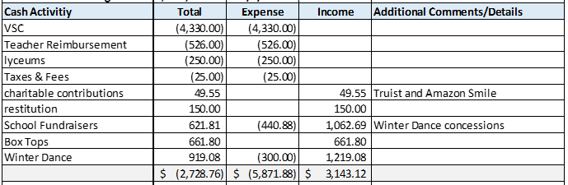

**Approval of January 2016 Meeting Minutes - Adriann Kell**

* Minutes approved with a few changes made.

**Parent/Teacher Open Forum – All**

* Thank you from Special Education department – t-shirts that were purchased and used as incentives for students has been a big success.

**Adjournment 8:22pm**

**2016/2017 PTO Board Members**

Jessica Wegener      President

Alex Olson                Vice President

Missy Persaud          Treasurer

Adriann Kell              Secretary